

MOTION PRO UNIVERSAL SPEEDOMETER CABLE KITS
P/N 01-0107 & 01-0112

1. Inspect cable housing to be sure there are no breaks and no pieces of old inner wire inside cable housing. Carefully measure inner wire and match end fitting with one of three fittings included in kit.

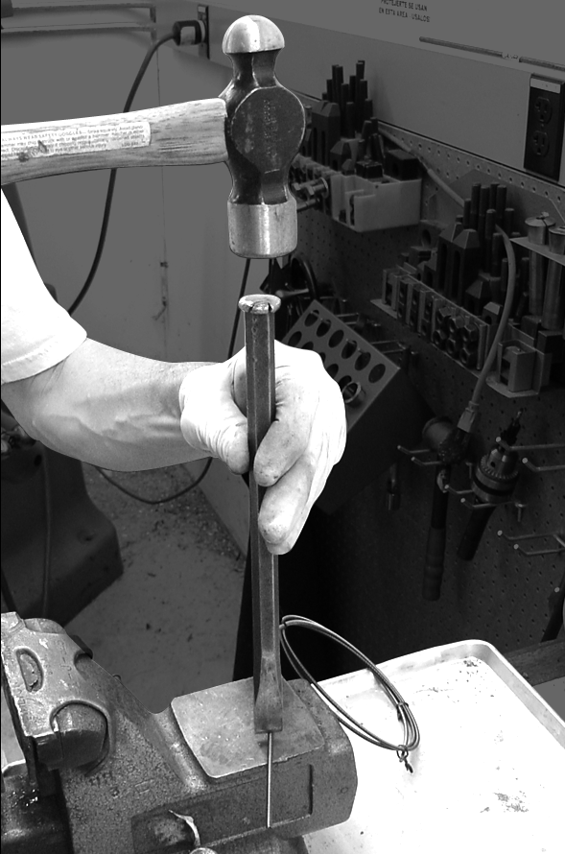
2. Deduct 5/8” (16mm) from measurement and cut new cable to this length. Be sure to cut round end of cable - do not cut squared end. Best way to cut the new inner cable is to use a sharp chisel and hammer. Use a flat metal surface and place the chisel on the cable. Strike the chisel with hammer using a strong blow. USE EYE PROTECTION. (See figure 1)

3. Insert correct tip on cut end. Stake tip with tool provided using a hammer blow or vise.
(See figures 2 and 3)

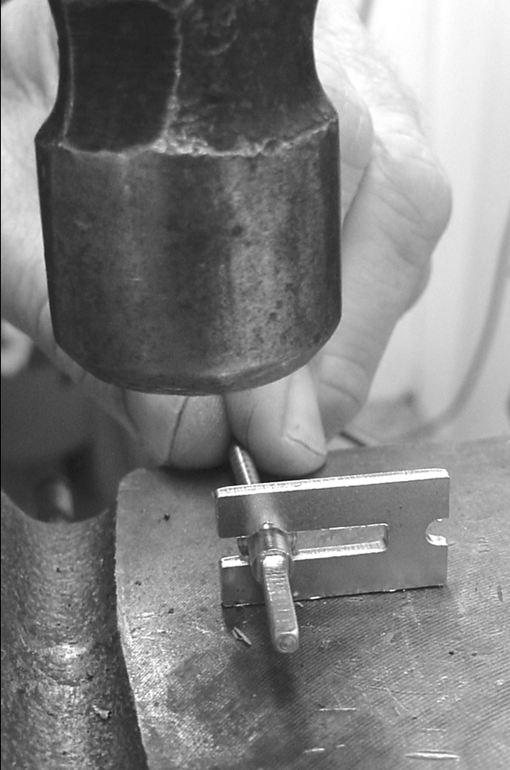
FIG.2

FIG.1

4. Lightly lubricate with waterproof grease and
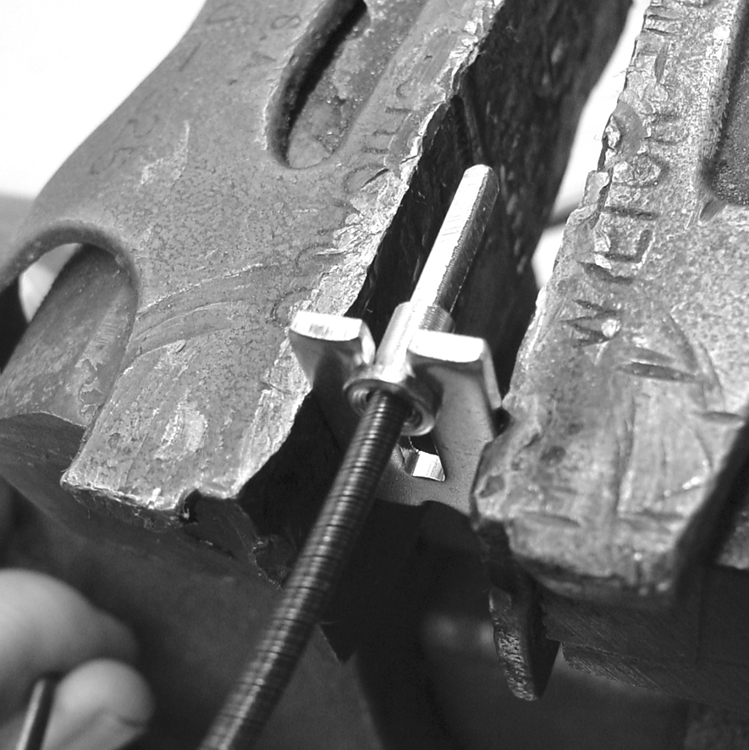
insert new cable.
FIG.3

I01-0107 10/2010

